**CMS management**

All public pages of the website

Don’t forget to display the View statistics, view campaign and print agreement from Constant Emails, you can find them at <http://constantemails.com/admin/list_users.php> username: 1 Password: 123456

There should be announcements like the one in the email marketing service’s dashboard in all three dashboards; one in Email marketing, one in Event and one in survey. There should also be an announcement in the combined main dashboard for public, general announcements.

Make sure user packages in admin panel <http://beta.constanttarget.com/Admin/UserPackages.aspx> list the services the user is currently signed up to.

**Monitoring quota usage**

In <http://beta.constanttarget.com/Admin/UserPackages.aspx> create a new column called “Quota usage” where there will be a link with text “View” which upon clicking displays a window containing a table with specific information on the user’s quota usage for the particular service.

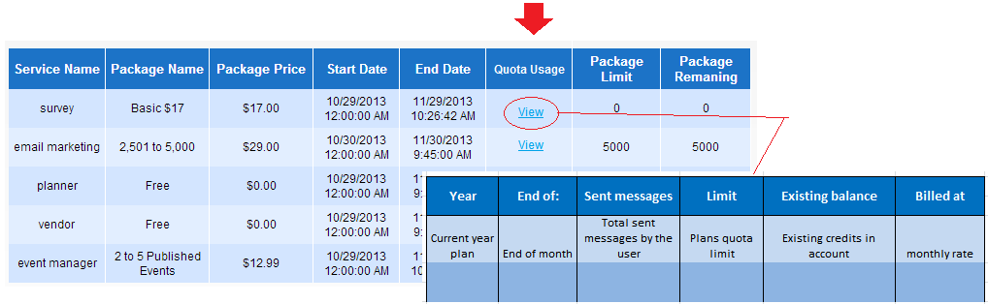

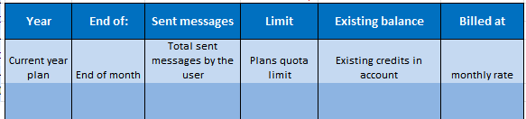

In the below examples we will look at different case scenarios and how they would display on the above table.

Example of a prepaid 6 months membership with a user who DID NOT change/upgrade/exceed his plan’s quota.

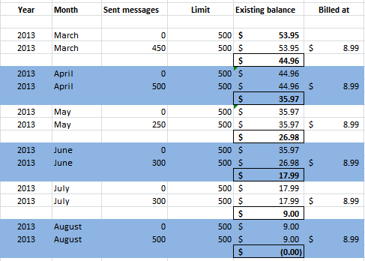

Notice how this user stayed within his quota limits. Notice also how this user only used 250 of his 500 email quota in May, but was still billed for 500. In this example the user was billed at 19.99 minus 10% discount which is $8.99

Example of a prepaid 6 months membership with a user who DID NOT change/upgrade/exceed his plan’s quota.

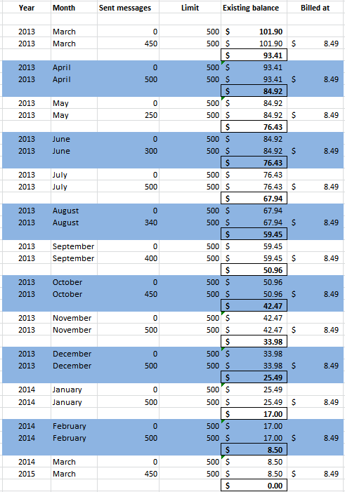

Notice how this user also stayed within his 500 email limits, in this example the user was billed at 19.99 minus 15% discount which comes up to $8.49

The next examples will display how the system will report quota **overuse**.

Example of a prepaid 6 months membership with a user exceeding his plan quota in may:

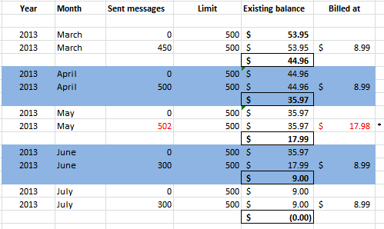

*User exceeded his quota on **[date he exceeded his quota]** sending **[sent messages – agreed quota limit]** so he was billed at **[adjusted billing rate].**

Notice how this user’s estimated usage is shortened to 5 months. This user sent 502 emails which caused the system to bill the user at the 501-1000 emails rate. In this example the user was billed at 19.99 minus 10% discount. Table in this case only displays data from March to July with August not being displayed because user run out of funds before August.

Example of a prepaid 12 months membership with a user exceeding his plan quota in July:

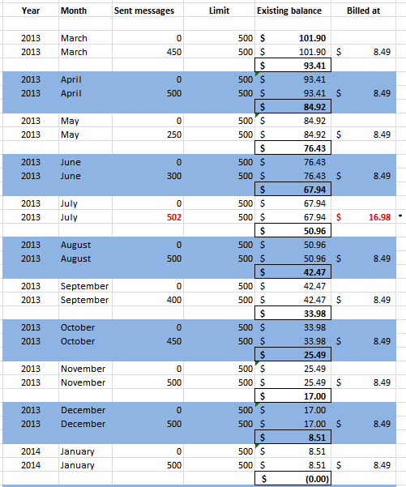

*User exceeded his quota on [**date he exceeded his quota]** sending **[sent messages – agreed quota limit]** so he was billed at **[adjusted billing rate]**.

Notice how this user’s estimated usage is shortened to 11 months. This user sent 502 emails which caused the system to bill the user at the 501-1000 emails rate. In this example the user was billed at 19.99 minus 15% discount which equals $8.49.

Example of a prepaid 12 months membership with a user exceeding his plan quota in July and again in August.

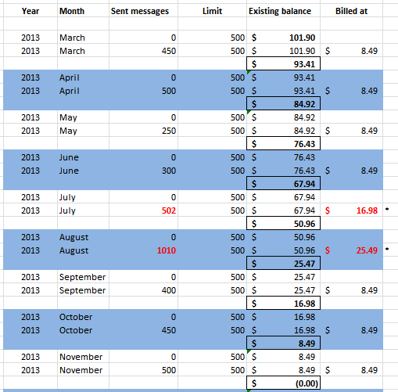

*User exceeded his quota on **[date he exceeded his quota]** sending **[sent messages – agreed quota limit]** so he was billed at **[adjusted billing rate].**

*User exceeded his quota on **[date he exceeded his quota]** sending **[sent messages – agreed quota limit]** so he was billed at **[adjusted billing rate].**

Notice how this user’s estimated usage is shortened to 9 months instead of the initial estimated 12. This user sent 502 emails in July and 1010 emails in August which caused the system to bill the user at the 501-1000 emails rate in July and at the 1001-2500 emails in August. In this example the user was billed at $19.99 minus 15% discount in July and $29.97 minus 15% discount in August.

**Adding funds to his plan**

A user may add funds to his plan which would simply increase his estimated usage at the agreed rate. In this case the table would reflect the following:

As seen in previous example, the below table reports that a user exceeded his quota twice in the 12 month period which caused the system to bill such user at higher rates thus decreasing his estimated usage from 12 months to 9 months.



If the above user were able were able to predict such outcome and wanted to fix it so he could still use the services for a time close to the initial estimated one, then he could add funds for the particular service so to extend his usage. In the below table we display the same user predicting he would run out of funds too soon and adding 4 months of service to his plan.

On September the user adds four months worth of service at $9.99 for which he gets a 15% discount per month because his plan is still current (otherwise he would have to pay month to month without the discount) all of which comes out to (9.99 x 4 = 39.96 -10%)**$33.97.**

As seen on above table, we see that the user’s remaining balance at the end of September is $16.99 so if he adds $33.97 his balance goes up to $50.95. See reflected changes below:

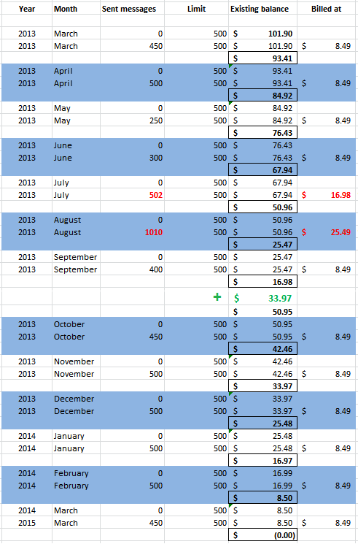

**Changing plans**

For users who change/upgrade/downgrade their plan the table simply shows the new billing rate at which they are being charged until their funds run out.

Because of how unpredictable such changes can be and because there is no certainty that the plan the user chooses will evenly use up the entire user’s remaining credits we would be forced to restrict the amount of emails he can send when his remaining balance does not permit the user to be billed at a rate which is greater than his remaining balance.

**Example:**

A user whose remaining balance is $9.00 is restricted to stay within the 0- 500 emails which costs $8.49 after the discount has been applied. Under no circumstance can this user exceed 500 emails because his remaining.

See example of a user who switched from the 1-500 emails to the 501-1000 emails at the beginning of his prepaid 6 month plan

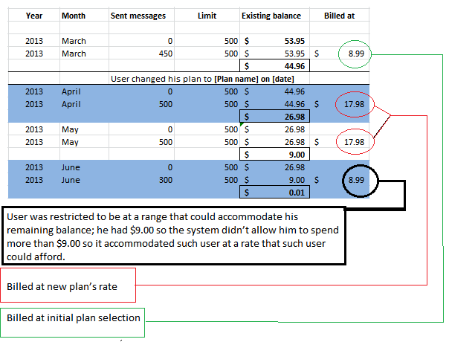

**General Observations**

* Make sure a user cannot consume a dollar amount worth of service greater than what his remaining balance can cover. If a user has $16.99 left in his account during A 6 month pre-pay plan we know according to above examples that that amount equals 2 months of the “1 to 500 emails” plan at $8.49 ($9.99 – 10%) or 1 month of the “501-1000 emails” plan at $16.98($19.99 – 10%). Under no circumstance can the system allow the user be billed at the $29.97 rate simply because he doesn’t have $29.97 in his account. So to put things in a quota perspective the user with $16.99 can send 1000 emails all in one shot, run out of funds and end his prepay period.
* The tables here MUST have all detailed information of any overuse, addition of funds and/or changes of plan.
* User must have an option that allows him to add funds to his balance. This process would require the user to use his PayPal account or to enter a new credit card.